student
[Email address]
Abstract
[Draw your reader in with an engaging abstract. It is typically a short summary of the document.
When you’re ready to add your content, just click here and start typing.]
E-Commerce
Shop, Enjoy

Contents
1. Project Overview 2
1.1 Introduction 2
Deep Analysis 2
2. Purpose of the System 2
3. Scope of the Project 3
User Activities 3
Administrative Activities 3
Vendor Activities (Optional) 3
4. Business Problem Statement 4
5. System Architecture 5
Presentation Layer (Frontend) 5
Application Layer (Backend) 6
Data Layer (Database) 7
6. User Roles and Responsibilities 7
6.1 User 7
User Benefits 7
6.2 Administrator 9
6.3 Vendor (Optional) 9
7. Functional Requirements 9
7.1 User Registration and Authentication 9
Registration Process 9
Login Process 11
20. Conclusion 11

Figure 1 - ECommerce Intro 2
Figure 2 - Scope Of The Project 3
Figure 3- Programming Intro. 5

E-Commerce Web-Based Platform Documentation

Software Requirements Specification (SRS) & System Documentation

1. Project Overview


1.1 Introduction
Figure 1 - ECommerce Intro
T
the E-Commerce Web-Based Platform is a digital marketplace designed to facilitate the buying and selling of products through an online environment. The platform enables users to browse products, compare prices, add products to their shopping cart, place orders, make payments securely, and track deliveries from anywhere and at any time.
MY TEXT
The primary goal of this platform is to provide businesses with an efficient and scalable solution for conducting online sales while offering users a convenient, secure, and user-friendly shopping experience.
اس پلیٹ فارم کا بنیادی مقصد کاروباروں کو آن لائن فروخت کے لیے ایک مؤثر اور قابل توسیع حل فراہم کرنا ہے جبکہ صارفین کو آسان، محفوظ اور صارف دوست خریداری کا تجربہ فراہم کرنا ہے۔
In today's digital economy, users expect seamless online shopping experiences with fast navigation, secure payment processing, and reliable order fulfillment. This system addresses these requirements by integrating inventory management, user relationship management, order processing, payment gateways, and reporting functionalities into a centralized platform.
Video provides a powerful way to help you prove your point. When you click Online Video, you can paste in the embed code for the video you want to add. You can also type a keyword to search online for the video that best fits your document.

Deep Analysis
The platform supports multiple user roles, including users, administrators, and vendors (optional), ensuring smooth business operations and effective management of online commerce activities.

2. Purpose of the System
The purpose of this E-Commerce platform is to digitize traditional retail operations and provide businesses with a centralized solution for managing products, users, orders, and payments.
The system aims to:
- Expand business reach beyond physical locations.
- Enable users to shop online 24/7.
- Automate inventory and order management processes.
- Provide secure online payment facilities.
- Improve user satisfaction through efficient order tracking and support.
- Generate detailed business analytics and reports for decision-making.

3. Scope of the Project
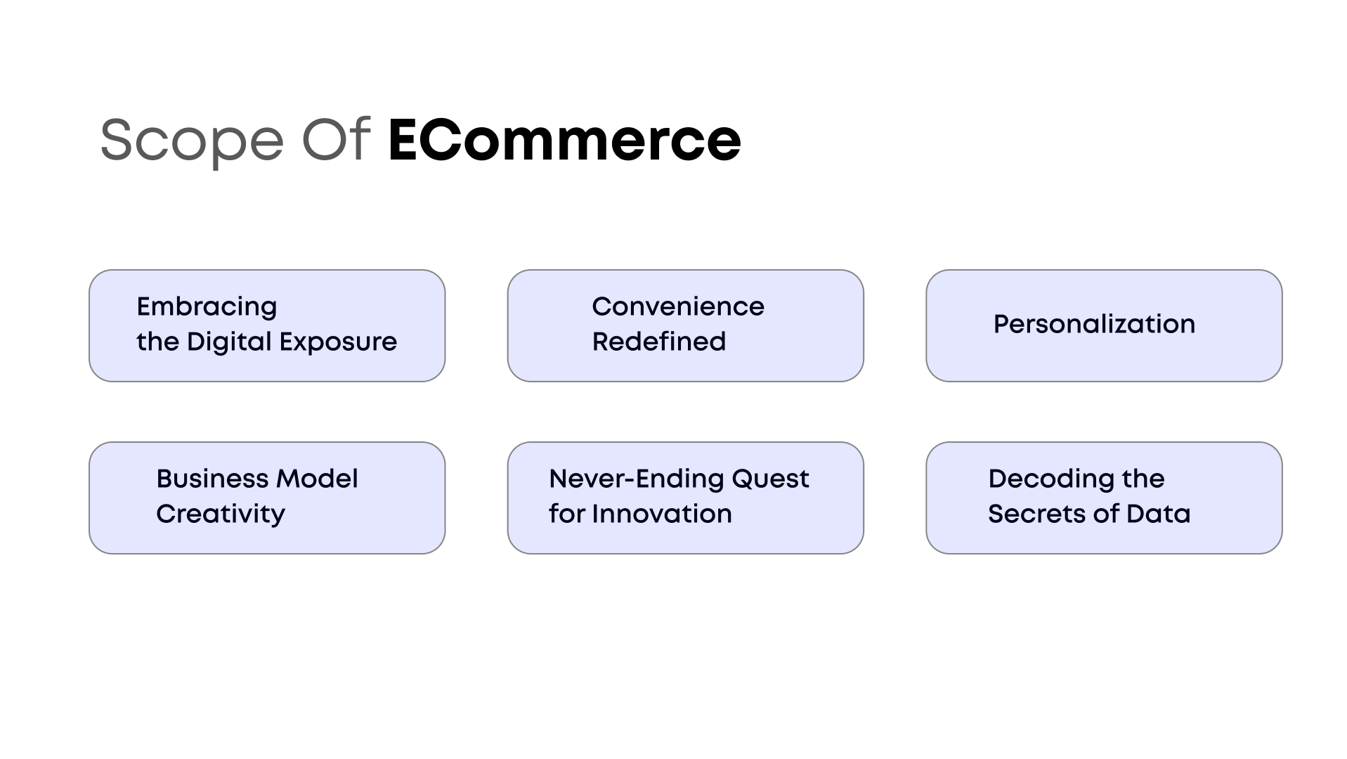

The E-Commerce Web Platform covers the complete online shopping lifecycle, including:
Figure 2 - Scope Of The Project
This Photo by Unknown Author is licensed under CC BY-SA-NC

User Activities
- User registration and authentication
- Product browsing and searching
- Shopping cart management
- Online order placement
- Payment processing
- Order tracking
- Product reviews and rating

Administrative Activities
- Product management
- Inventory management
- User management
- Order processing
- Sales reporting
- Discount and promotional campaign management

Vendor Activities (Optional)

The system can be deployed for various industries such as:
- Fashion and Apparel
- Electronics
- Home and Furniture
- Beauty Products
- Grocery Stores
- Pharmaceutical Products
- Multi-Vendor Marketplaces

4. Business Problem Statement
NOTE
Video provides a powerful way to help you prove your point. When you click Online Video,


Traditional retail businesses often face challenges such as limited geographical reach, manual inventory management, lack of real-time reporting, and restricted operating hours.
Users may experience inconvenience due to:
- Long queues
- Limited product availability
- Inability to compare products easily
- Restricted shopping hours
$$\frac{-2±\sqrt{2^{2}-43c}}{23}$$
$$x+ \frac{1}{x^{2}}$$
The proposed E-Commerce platform eliminates these issues by offering a centralized digital shopping experience accessible from any internet-enabled device.
29 June 2026
Monday, 29 June 2026

Figure 3- Programming Intro.
For more understanding, Read the Article

5. System Architecture
The platform follows a three-tier architecture:

Presentation Layer (Frontend)
The frontend serves as the user interface where users, administrators, and vendors interact with the system.

Responsibilities include:
- Displaying products
- Accepting user inputs
- Presenting shopping cart information
- Showing order status updates
- Providing responsive user experiences
Technologies:
- ReactJS
- HTML5
- CSS3
- Bootstrap / Tailwind CSS
- JavaScript

Application Layer (Backend)
The backend processes business logic and handles communication between the frontend and the database.
Responsibilities include:
- User authentication
- Product management
- Order processing
- Payment integration
- Inventory updates
- Report generation
Technologies:
- Node.js
- Express.js
- PHP Laravel
- RESTful APIs

Data Layer (Database)
The database stores all application data.
Responsibilities include:
- Product information
- User records
- Order details
- Payment records
- Inventory data
Technologies:
- MySQL
- PostgreSQL

6. User Roles and Responsibilities

6.1 User
Users are the primary users of the platform.
Their responsibilities include:
- Creating accounts
- Browsing products
- Adding products to cart
- Placing orders
- Making payments
- Tracking deliveries
- Providing reviews

User Benefits
- Convenience
- Secure transactions
- Personalized recommendations
- Order history access

Delivery Days & & Timings
Days | Opening Time | Closing Time
Monday | 8 AM | 8 PM
Tuesday | 8 AM | 8 PM
Wednesday | 8 AM | 8 PM
Thursday | 8 AM | 7 PM
Friday | 8 AM | 1 PM
Saturday | 9 AM | 7 PM

Revenue & Profits

Page | 7

6.2 Administrator
Administrators manage the entire platform.
Responsibilities include:
- Managing products
- Managing users
- Monitoring sales
- Processing orders
- Managing inventory
- Creating discounts
- Generating reports
The administrator has complete control over the platform and can access all modules.

6.3 Vendor (Optional)
Vendors can independently manage their stores within the platform.
Responsibilities include:
- Product uploads
- Inventory updates
- Order management
- User communication

7. Functional Requirements

7.1 User Registration and Authentication
The platform must provide secure registration and authentication mechanisms.

Registration Process
Users are required to provide:
- Full Name
- Email Address
- Phone Number
- Password
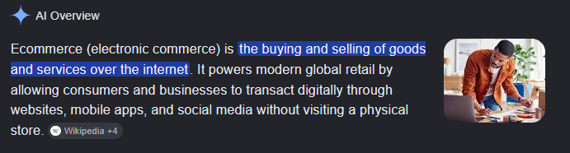
[Grab your reader’s attention with a great quote from the document or use this space to emphasize a key point. To place this text box anywhere on the page, just drag it.]
Upon successful registration:
- Verification email is sent.
- Account is activated after confirmation.

Login Process
Users authenticate using:
- Email Address
- Password

20. Conclusion
The E-Commerce Web-Based Platform serves as a complete digital commerce solution that streamlines online business operations while providing users with a secure and efficient shopping experience. Through its integrated modules—including user management, product management, inventory control, order processing, payment handling, reporting, and user relationship management—the platform supports the full e-commerce lifecycle.
The system is designed to be scalable, secure, and adaptable to the needs of businesses ranging from small startups to large enterprises. By leveraging modern web technologies and best practices, the platform helps organizations improve operational efficiency, increase revenue, enhance user engagement, and remain competitive in the rapidly evolving digital marketplace.
This documentation serves as a comprehensive reference for stakeholders, developers, project managers, testers, and future maintenance teams involved in the development and deployment of the E-Commerce Web-Based Platform.
I’ve mentioned earlier in the intro. Look bellow
T
he E-Commerce Web-Based Platform is a digital marketplace designed to facilitate the buying and selling of products through an online environment. The platform enables users to browse products, compare prices, add products to their shopping cart, place orders, make payments securely, and track deliveries from anywhere and at any time.

Bibliography
Doe John ECommerce 0 To Hero Guide [Book]. - Lahore : ABC Publishers, 2025.
Fareed Ali Programming Fundamentals [Book]. - Karachi : ABC Publishers, 2026.

(Fareed, 2026)
Took this from ABC Website
Took this from Article
Aliexpress.com
These points are not from ordinary mindset
(Doe, 2025)
Took This from Alex Smith’s Ecommerce Guide (Fareed, 2026) (Doe, 2025)

